# CS 255 System Design Document Template

## UML Diagrams

### UML Use Case Diagram

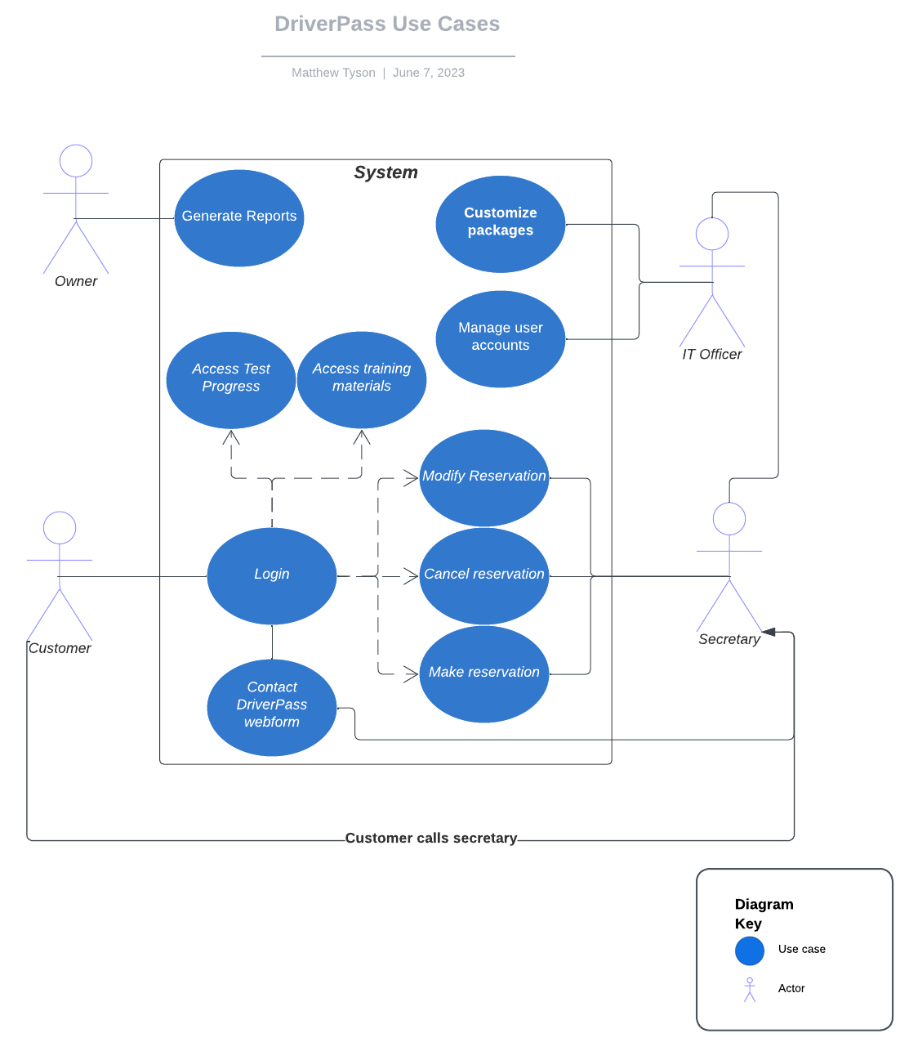

### UML Activity Diagrams

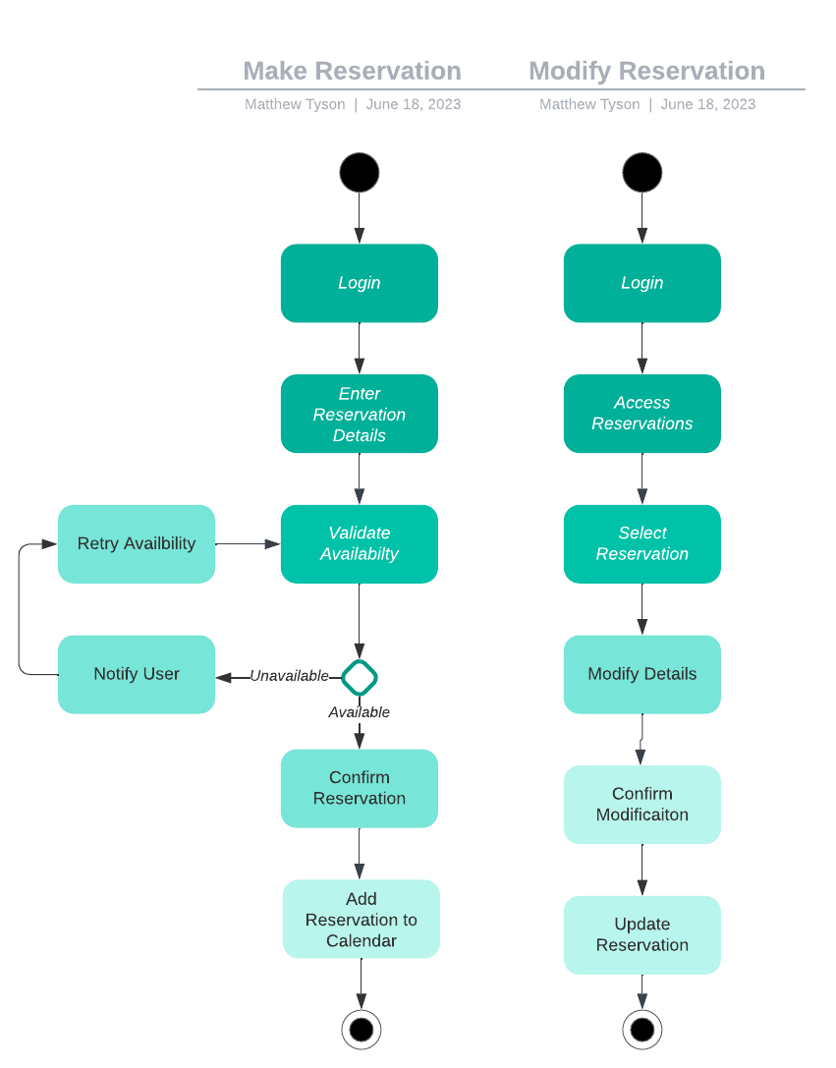

### UML Sequence Diagram

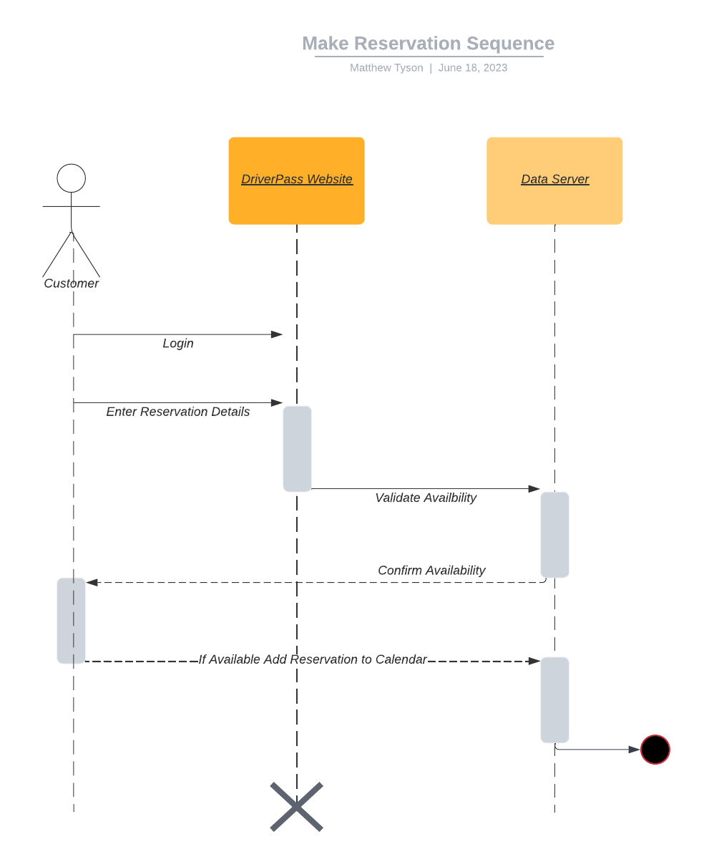

### UML Class Diagram

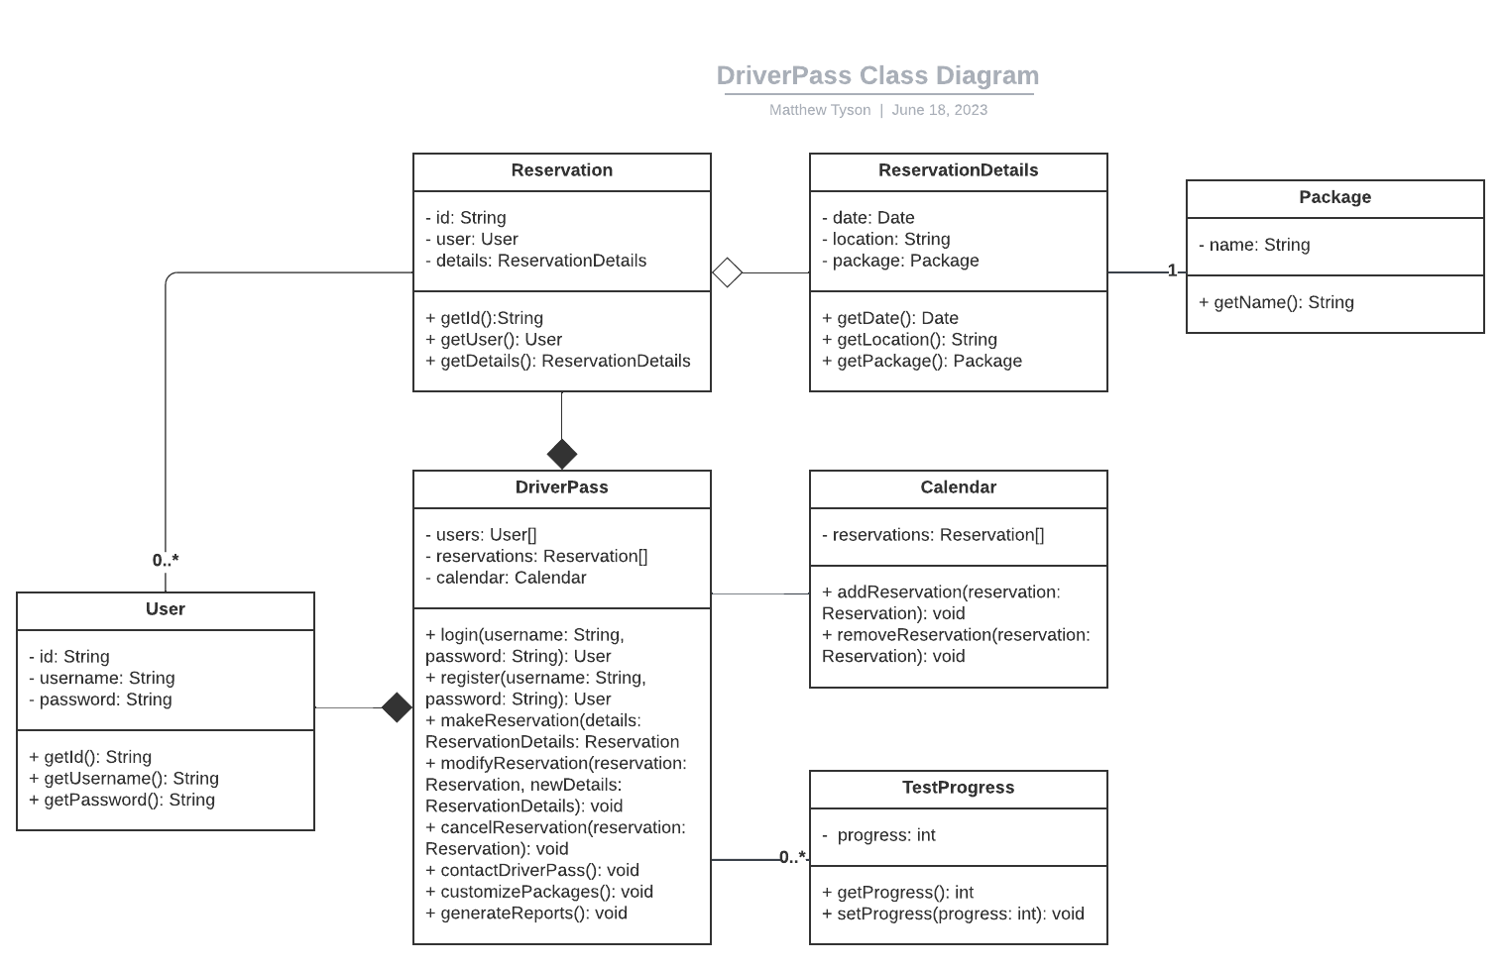

## Technical Requirements

Based on the diagrams created for the DriverPass system, the technical requirements can be described as follows:

Hardware Requirements:

* Server Infrastructure: A robust server infrastructure is needed to host the web-based application. It should have sufficient processing power, memory, and storage capacity to handle concurrent user requests and store the necessary data.

Software Requirements:

* Web Application Framework: The system should be built using a suitable web application framework that supports the development of dynamic and interactive web-based applications.
* Database Management System: A reliable and scalable database management system (DBMS) is required to store and manage customer information, reservations, test progress, and other relevant data.
* Operating System: The server infrastructure should run on a stable and secure operating system that is compatible with the selected web application framework and DBMS.
* Web Server: A web server software should be installed to handle incoming HTTP requests and serve the web application to clients.
* Integrated Development Environment (IDE): An IDE should be used for efficient development, debugging, and testing of the system components.

Infrastructure Requirements:

* Internet Connectivity: A stable and high-speed internet connection is necessary to ensure smooth communication between the web-based application and the clients accessing it.
* Cloud Hosting: The system should be hosted on a reliable and secure cloud platform to provide easy access from anywhere and ensure minimal technical problems. Cloud hosting also relieves the business from managing backups and security.
* Data Backup and Recovery: Regular data backups should be performed to prevent data loss in case of any unforeseen events. A backup and recovery strategy should be in place to ensure data integrity and availability.

Tools and Technologies:

* Lucidchart: Lucidchart, the CASE tool, can be used to create UML diagrams such as use case diagrams, activity diagrams, sequence diagrams, and class diagrams.
* Programming Languages: Depending on the chosen web application framework, programming languages like JavaScript, Java, Python, or others may be required to develop the system components.
* Database Modeling Tool: A database modeling tool can be used to design and visualize the database schema, relationships, and entities.

These technical requirements provide a high-level overview of the hardware, software, tools, and infrastructure needed for the successful design and implementation of the DriverPass system.

References

Dennis, A., Wixom, B. H., & Tegarden, D. (2012). *Systems analysis and design with UML* (4th ed.). Wiley. <https://learning.oreilly.com/library/view/systems-analysis-and/9781118037423/11_chapter006.html#ch006-sec001>